EXERCISE – 13 (K-MEANS CLUSTERING)
1. AIM
To perform K-Means clustering on the heart disease dataset and to use the Elbow Method to determine a suitable number of clusters.
2. ALGORITHM
1. Load the dataset and remove the target column Heart Disease.
2. Scale the numerical features and one-hot encode the categorical features to obtain the processed feature matrix.
3. Run K-Means for K = 1 to 10 and record the inertia of every run.
4. Plot the Elbow curve of inertia against K.
5. Select the optimal K and fit the final K-Means model.
6. Add the cluster labels to the dataset and count the records in each cluster.
3. PROGRAM
import pandas as pd
import matplotlib.pyplot as plt
from sklearn.compose import ColumnTransformer
from sklearn.preprocessing import StandardScaler, OneHotEncoder
from sklearn.cluster import KMeans
df = pd.read_csv("heart_disease_dataset.csv")
print("Dataset Shape:", df.shape)
print("\nFirst 5 records:")
print(df.head())
X = df.drop("Heart Disease", axis=1)
numeric_features = X.select_dtypes(
include=["int64", "float64"]
).columns
categorical_features = X.select_dtypes(
include=["object"]
).columns
preprocessor = ColumnTransformer(
transformers=[
("num", StandardScaler(), numeric_features),
("cat", OneHotEncoder(handle_unknown="ignore"), categorical_features)
]
)
X_processed = preprocessor.fit_transform(X)
# Check whether X_processed is sparse or already a NumPy array
if hasattr(X_processed, "toarray"):
X_processed = X_processed.toarray()
print("\nProcessed Data Shape:")
print(X_processed.shape)
# ------------------------------------------------------------
# Step 7: Apply Elbow Method
# ------------------------------------------------------------
inertia = []
K = range(1, 11)
for k in K:
kmeans = KMeans(
n_clusters=k,
random_state=42,
n_init=10
)
kmeans.fit(X_processed)
inertia.append(kmeans.inertia_)
plt.figure(figsize=(8, 5))
plt.plot(
K,
inertia,
marker="o"
)
plt.xlabel("Number of Clusters (K)")
plt.ylabel("Inertia")
plt.title("Elbow Method for Optimal K")
plt.xticks(K)
plt.grid(True)
plt.show()
# Change this value after observing the elbow plot.
optimal_k = 3
print("\nSelected Optimal K:", optimal_k)
kmeans = KMeans(
n_clusters=optimal_k,
random_state=42,
n_init=10
)
clusters = kmeans.fit_predict(X_processed)
df["Cluster"] = clusters
print("\nClustered Dataset:")
print(df.head(10))
print("\nNumber of records in each cluster:")
print(df["Cluster"].value_counts().sort_index())

4. OUTPUT
The program was executed on the Heart disease dataset (heart_disease_dataset.csv) and produced the following output:
Dataset Shape: (1000, 16)
First 5 records:
Age Gender ... Chest Pain Type Heart Disease
0 75 Female ... Atypical Angina 1
1 48 Male ... Typical Angina 0
2 53 Male ... Atypical Angina 1
3 69 Female ... Non-anginal Pain 0
4 62 Female ... Asymptomatic 0
[5 rows x 16 columns]
Processed Data Shape:
(1000, 27)
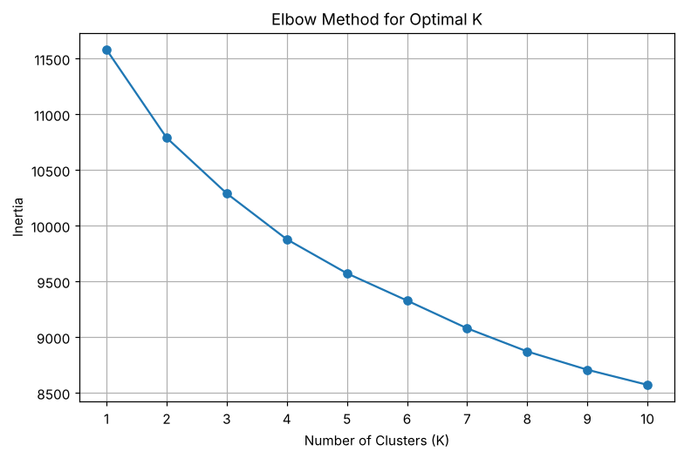
Selected Optimal K: 3
Clustered Dataset:
Age Gender Cholesterol ... Chest Pain Type Heart Disease Cluster
0 75 Female 228 ... Atypical Angina 1 0
1 48 Male 204 ... Typical Angina 0 1
2 53 Male 234 ... Atypical Angina 1 0
3 69 Female 192 ... Non-anginal Pain 0 1
4 62 Female 172 ... Asymptomatic 0 0
5 77 Male 309 ... Asymptomatic 1 0
6 64 Female 211 ... Typical Angina 1 1
7 60 Female 208 ... Asymptomatic 1 1
8 37 Female 317 ... Non-anginal Pain 0 2
9 63 Male 204 ... Asymptomatic 1 1
[10 rows x 17 columns]
Number of records in each cluster:
Cluster
0 308
1 337
2 355
Name: count, dtype: int64

5. RESULT
Thus, the K-Means Clustering practical was implemented successfully. The Elbow curve indicated K = 3 as a suitable number of clusters, and the 1000 records were grouped into clusters of 308, 337 and 355 records.

